**Enterprise Resource Planning**

**Training User Manual**

**VERSION 12.0.0**

**Attendance Reports**

**Index**

|  |  |
| --- | --- |
| **About** | **Page No.** |
| * **Attendance Reports Location** | **03** |
| * Daily Working Hour Report | **04** |
| * Daily Attendance Info | **05** |
| * Monthly Attendance Info (ALL) | **06** |
| * Monthly Attendance Summary | **07** |
| * Employee Job Card Summary | **08** |
| * Employee Attendance(Detail) | **09** |
| * Employee Duty Schedule | **10** |
| * Late & Early for approval | **11** |
| * Employee Roster | **12** |
| * Date Wise Roster | **13** |
| * Card Punch Data | **14** |
| * Replacement & Holiday Duty | **15** |
| * Employee Absent List | **16** |

**Attendance Reports**

|  |  |
| --- | --- |
| **Step 1** | Open System **>** Attendance Information **> Reports** |
| **Step 2** | Select the Report option to show any Report |
| **Step 3** | Fix the required Parameters and then click on **View Report** Button |

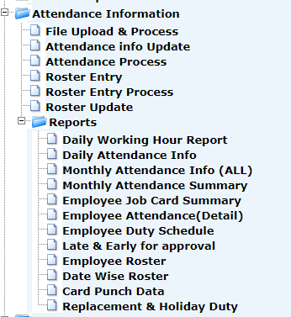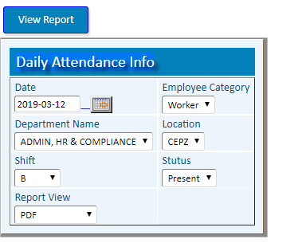

1. **Daily Working Hour Report**

**(To Show the number of present Staffs, Working hours, OT)**

|  |  |
| --- | --- |
| **Step 1** | Open System **>** Attendance Information **> Reports** |
| **Step 2** | Select the Report option to show any Report |
| **Step 3** | Pick the desired Date and then click on **View Report** Button |

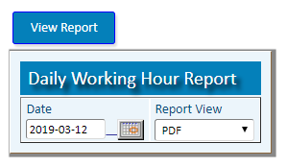

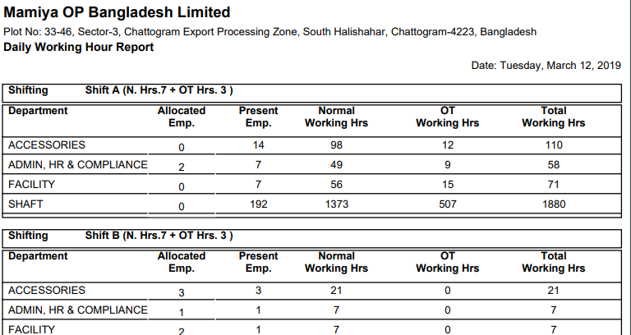

1. **Daily Attendance Info**

**(To Show department wise staff attendance status)**

|  |  |
| --- | --- |
| **Step 1** | Open System **>** Attendance Information **> Reports** |
| **Step 2** | Select the Report option to show any Report |
| **Step 3** | Pick the desired Date, Staff Category, department, Location , shift and then click on **View Report** Button |

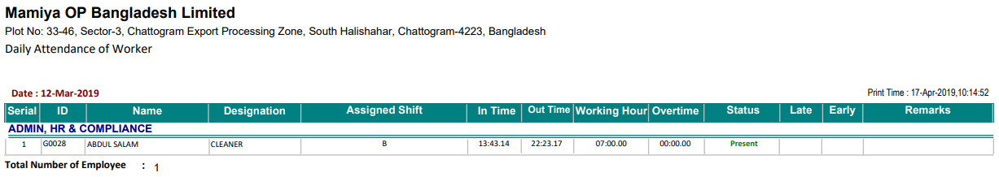

1. **Monthly Attendance Info (ALL)**

**(To Show all day in time, out time of any month)**

|  |  |
| --- | --- |
| **Step 1** | Open System **>** Attendance Information **> Reports** |
| **Step 2** | Select the Report option [**Monthly Attendance Info (ALL)**](http://localhost:8080/zab/login?screen=*viewcrystal+pdattdetailalld%285%3Bin%2Cst%2Cst%2Cin%2Cin%3Bzid%2Cempcat%2Cdept%2Cyear%2Cper%3Bxempcategory%3DEmployee+Category%2Cxdeptname%3DDepartment+Name%2Cxyear%3DYear%2Cxper%3DMonth%2Cxviewtype%3DReport+View%29&option=Monthly+Attendance+Info+%28ALL%29&menuname=pdatrep) |
| **Step 3** | Select the desired Staff Category, department, Year , Month and then click on **View Report** Button |

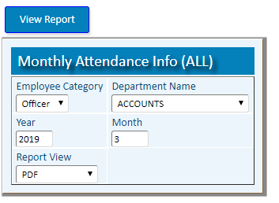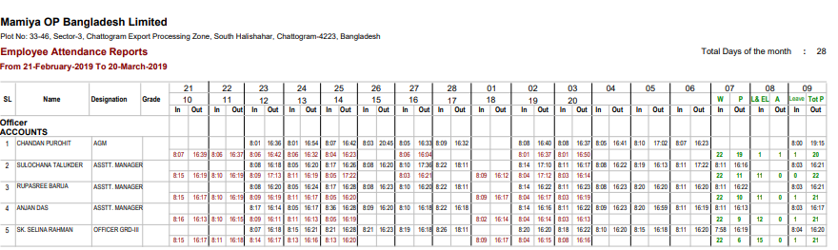

1. **Monthly Attendance Summary**

**(To Show all days attendance status of any month)**

|  |  |
| --- | --- |
| **Step 1** | Open System **>** Attendance Information **> Reports** |
| **Step 2** | Select the Report option [**Monthly Attendance Summary**](http://localhost:8080/zab/login?screen=*viewcrystal+pdattsumd%285%3Bin%2Cst%2Cst%2Cin%2Cin%3Bzid%2Cempcat%2Cdept%2Cyear%2Cper%3Bxempcategory%3DEmployee+Category%2Cxdeptname%3DDepartment+Name%2Cxyear%3DYear%2Cxper%3DMonth%2Cxviewtype%3DReport+View%29&option=Monthly+Attendance+Summary&menuname=pdatrep) |
| **Step 3** | Select the desired Staff Category, department, Year , Month and then click on **View Report** Button |

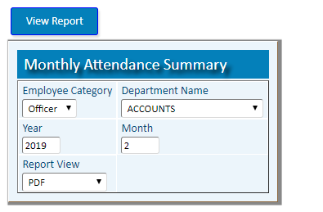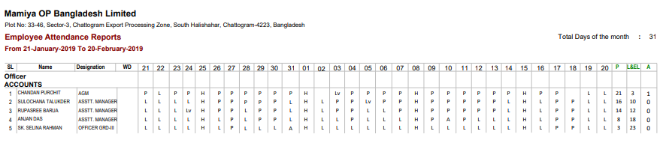

1. **Employee Job Card Summary**

**(To Show the day number of present, late, leave Working hours, OT)**

|  |  |
| --- | --- |
| **Step 1** | Open System **>** Attendance Information **> Reports** |
| **Step 2** | Select the Report option **Employee Job Card Summary** |
| **Step 3** | Select the desired Staff Category, department, Year , Month and then click on **View Report** Button |

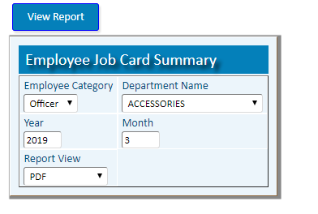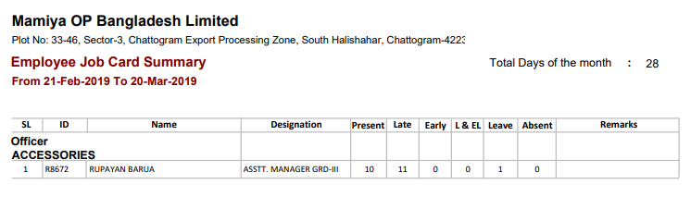

1. **Employee Attendance(Detail)**

**(To Show date wise attendances of any Staff)**

|  |  |
| --- | --- |
| **Step 1** | Open System **>** Attendance Information **> Reports** |
| **Step 2** | Select the Report option **Employee Attendance(Detail)** |
| **Step 3** | Pick start date, End date, staff ID and then click on **View Report** Button |

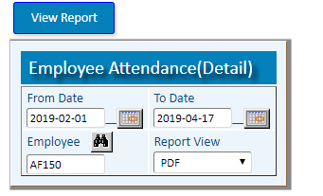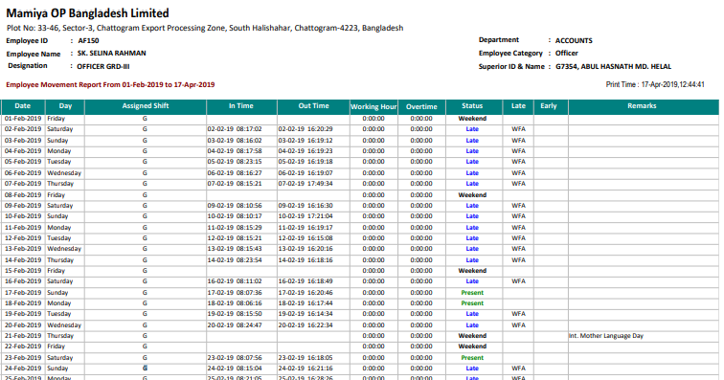

1. **Employee Duty Schedule**

**(To Show date wise attendances with in time, out time of any Staff)**

|  |  |
| --- | --- |
| **Step 1** | Open System **>** Attendance Information **> Reports** |
| **Step 2** | Select the Report option [**Employee Duty Schedule**](http://localhost:8080/zab/login?screen=*viewcrystal+pddutyschedule%286%3Bin%2Cst%2Cst%2Cst%2Cst%2Cst%3B%40zid%2C%40fdate%2C%40tdate%2C%40empcat%2C%40staff%2C%40adminid%3Bxdate%3DFrom+Date%3D%23date%2Cxdate%3DTo+Date%3D%23date%2Cxhide%3DHide%2Cxstaff%3DEmployee%2Cxhide%3Dadmin+ID%2Cxviewtype%3DReport+View%29&option=Employee+Duty+Schedule&menuname=pdatrep) |
| **Step 3** | Pick start date, End date, staff ID and then click on **View Report** Button |

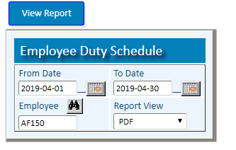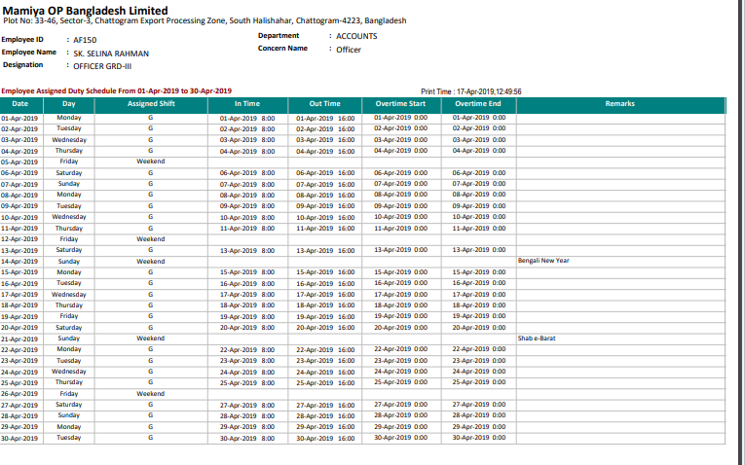

1. **Late & Early for approval**

**(To Show Late & Early leave)**

|  |  |
| --- | --- |
| **Step 1** | Open System **>** Attendance Information **> Reports** |
| **Step 2** | Select the Report option **Late & Early for approval** |
| **Step 3** | Pick Start Date, End Date, Staff Category, Superior ID and then click on **View Report** Button |

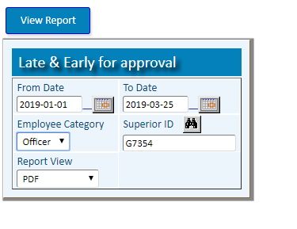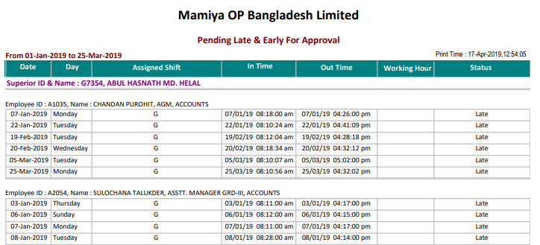

1. **Employee Roster**

**(To Show the Staff Rosters)**

|  |  |
| --- | --- |
| **Step 1** | Open System **>** Attendance Information **> Reports** |
| **Step 2** | Select the Report option [**Employee Roster**](http://localhost:8080/zab/login?screen=*viewcrystal+pdroster%284%3Bin%2Cst%2Cst%2Cst%3Bzid%2Croster%2Cstaff%2Cempcat%3Bxroster%3DRoster%2Cxstaff%3DEmployee+ID%2Cxhide%3DHide%2Cxviewtype%3DReport+View%29&option=Employee+Roster&menuname=pdatrep) |
| **Step 3** | Write the roster no., Staff ID and then click on **View Report** Button |

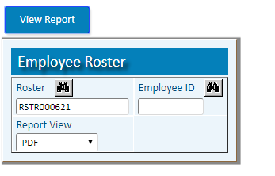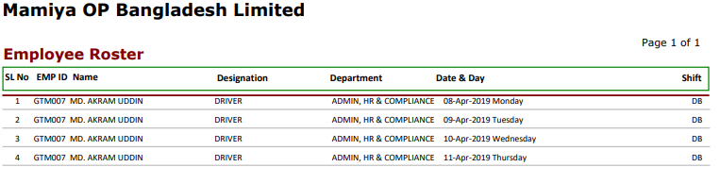

1. **Date Wise Roster**

**(To Show date wise roster of Staff)**

|  |  |
| --- | --- |
| **Step 1** | Open System **>** Attendance Information **> Reports** |
| **Step 2** | Select the Report option [**Date Wise Roster**](http://localhost:8080/zab/login?screen=*viewcrystal+pdrosterdate%286%3Bin%2Cdt%2Cdt%2Cst%2Cst%2Cst%3Bzid%2Cfdate%2Ctdate%2Cgroup%2Cstaff%2Cempcat%3Bxdate%3DFrom+Date%2Cxdate%3DTo+Date%2Cxempgroup%3DGroup+Name%2Cxstaff%3DEmployee+ID%2Cxhide%3DHide%2Cxviewtype%3DReport+View%29&option=Date+Wise+Roster&menuname=pdatrep) |
| **Step 3** | Pick Start Date, End Date, Staff ID and then click on **View Report** Button |

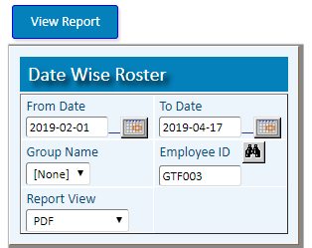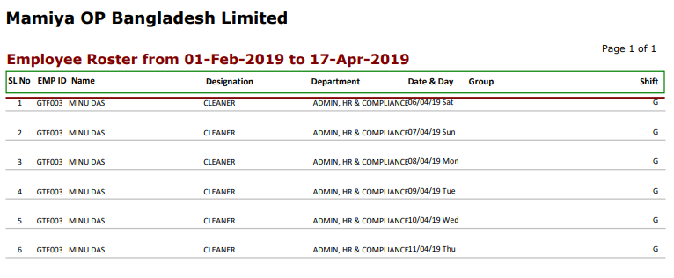

1. **Card Punch Data**

**(To Show all Punch of present Staffs)**

|  |  |
| --- | --- |
| **Step 1** | Open System **>** Attendance Information **> Reports** |
| **Step 2** | Select the Report option [**Card Punch Data**](http://localhost:8080/zab/login?screen=*viewcrystal+pdattenreport%284%3Bin%2Cdt%2Cdt%2Cst%3Bzid%2Cfdate%2Ctdate%2Cstaff%3Bxdate%3DFrom+Date%2Cxdate%3DTo+Date%2Cxstaff%3DEmp.+ID%2F+Card+No%2Cxviewtype%3DReport+View%29&option=Card+Punch+Data&menuname=pdatrep) |
| **Step 3** | Pick Start Date, End Date, Staff ID and then click on **View Report** Button |

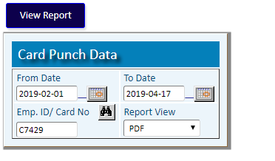

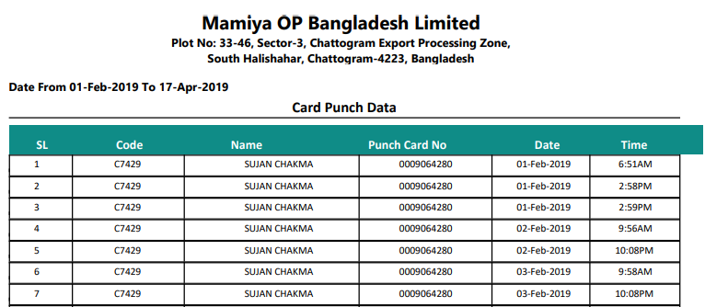

1. **Replacement & Holiday Duty**

**(To Show the Replacement & Holiday Duty of staffs)**

|  |  |
| --- | --- |
| **Step 1** | Open System **>** Attendance Information **> Reports** |
| **Step 2** | Select the Report option [**Replacement & Holiday Duty**](http://localhost:8080/zab/login?screen=*viewcrystal+pdhotreplv%285%3Bin%2Cst%2Cst%2Cst%2Cst%3B%40zid%2C%40fdate%2C%40tdate%2C%40pstaff%2C%40ptype%3Bxdate%3DFrom+Date%2Cxdate%3DTo+Date%2Cxstaff%3DEmp.+ID%2Cxdutytype%3DDuty+Type%2Cxviewtype%3DReport+View%29&option=Replacement+%26+Holiday+Duty&menuname=pdatrep) |
| **Step 3** | Pick Start Date, End Date, Staff ID, Duty Type(Replace/ OT) and then click on **View Report** Button |

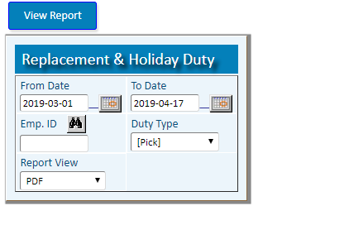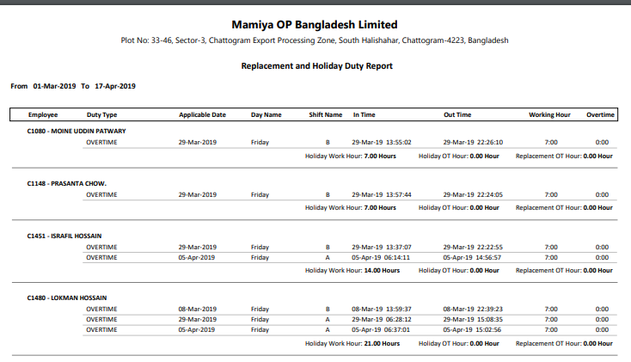

1. **Employee Absent List**

**(To Show the Day & Department wise Absent List of staffs)**

|  |  |
| --- | --- |
| **Step 1** | Open System **>** Attendance Information **> Reports** |
| **Step 2** | Select the Report option [**Employee Absent List**](http://localhost:5080/zab/login?screen=*viewcrystal+pdabsentlist%285%3Bin%2Cst%2Cst%2Cst%2Cst%3B%40zid%2C%40pfdate%2C%40ptdate%2C%40empcat%2C%40dept%3Bxdate%3DFrom+Date%2Cxdate%3DTo+Date%2Cxempcategory%3DEmp.+Category%2Cxdeptname%3DDepartment%2Cxviewtype%3DReport+View%29&option=Employee+Absent+List&menuname=pdatrep) |
| **Step 3** | Pick Start Date, End Date, Staff Category, Department and then click on **View Report** Button |

